**CONTEXT LEVEL**

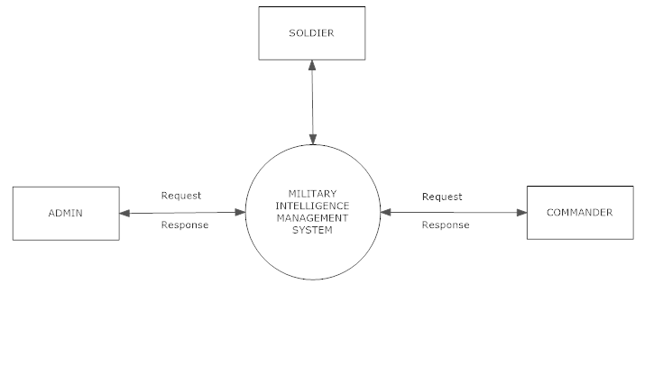

**LEVEL 1 FOR ADMIN**

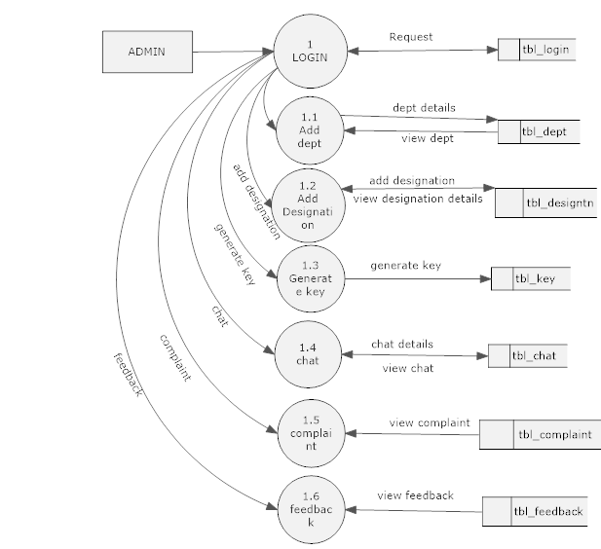

**LEVEL 1 FOR COMANDER**

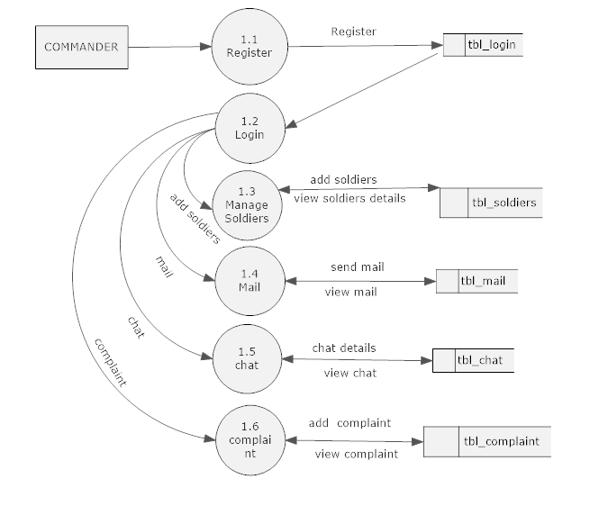

**LEVEL 1 FOR SOLDIER**

